WEEK05GATE05 Test Report

  - Project Information
  - Project Name: Advance Playwright and debugging
Participant: Athuldev U
Date:04-07-2026
Branch: athuldev-week05-gate5

1. Objective
The objective of this project is to automate and validate important retail application workflows using Playwright.It help to make the tests more genuine with more proof by using artifact and log.This will help to document the test wih more proof and keep a log with the test
2. Setup and Environment
Language Used: TypeScript
Framework : Playwright
Operating System : Windows
FrontEnd Url : http://localhost:5173
BackendEnd Url : http://localhost:4000

Configuration:
projects: [
{
name: "chromium",
use: { ...devices["Desktop Chrome"] }
}
]

baseURL: http://localhost:5173

3. Flow Under Test

Scenario 1:Get flacky login in the app
To make the test flacky we are using explicit time out 200 ms and not waiting for the login button to visible in the screen before it we are clicking so this will give flacky test
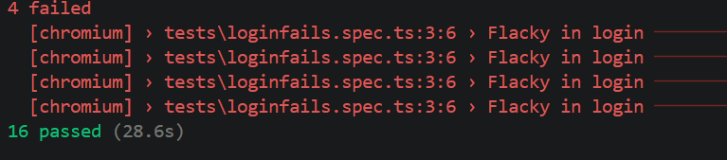
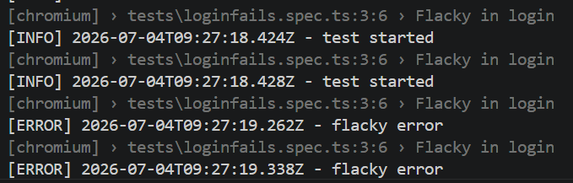
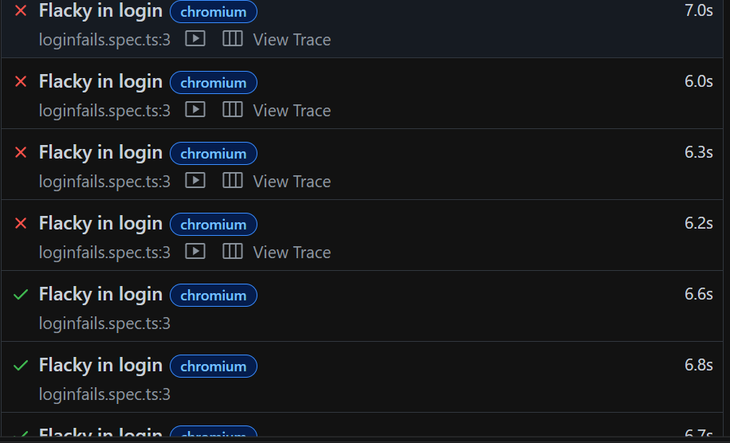
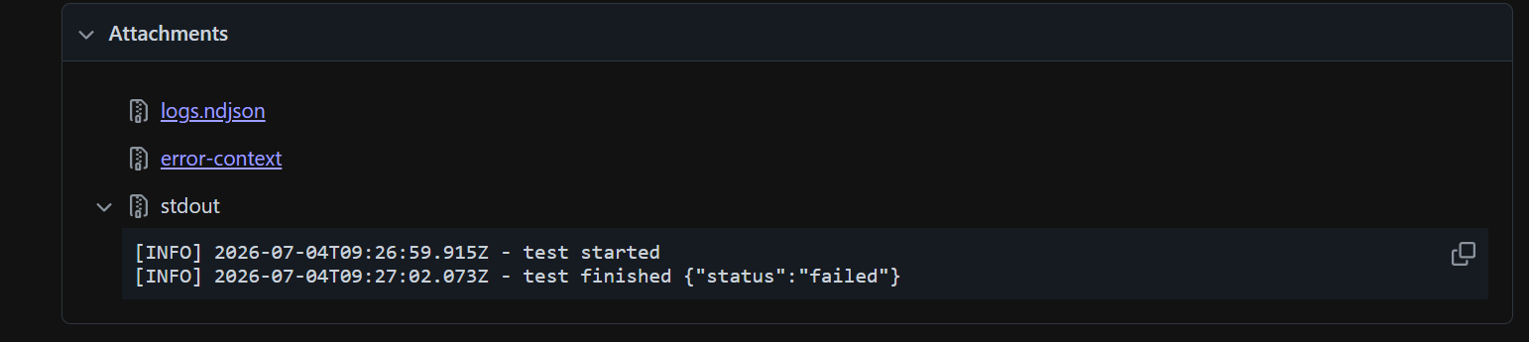
This are the artifact that are generated for the failed test
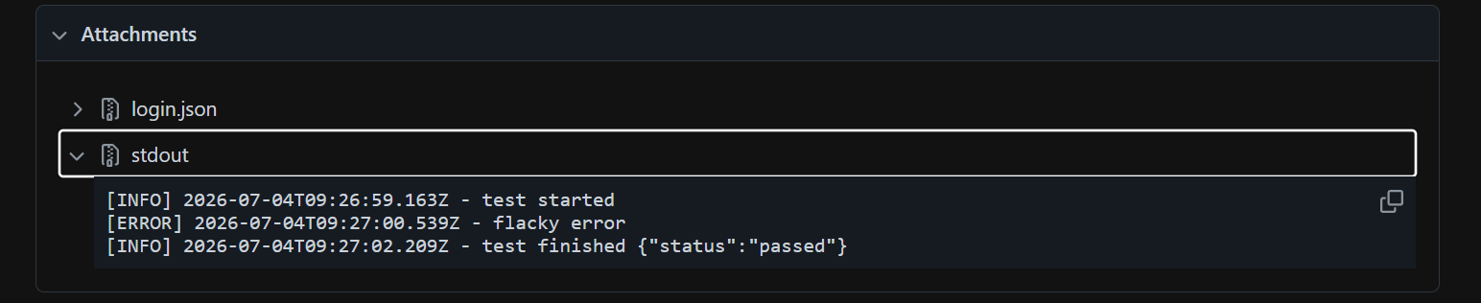
Above is the artifact that is generated for the failed test cases
After fixing the explicit wait and using autowait we can resolve this issue
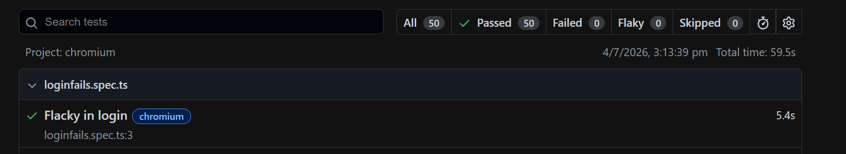

Scenario 2: Cart off by total
Here we are checking the cart of by a paisa to do that we will place an order and make refund of one product and take that response body and check the assert the value by increasing by one so it will give an error
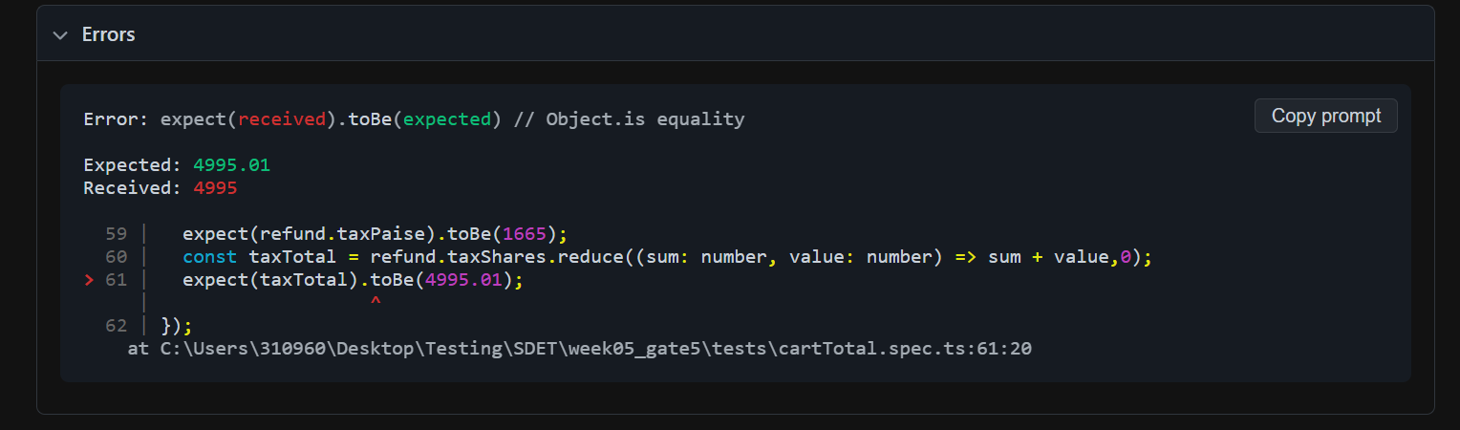
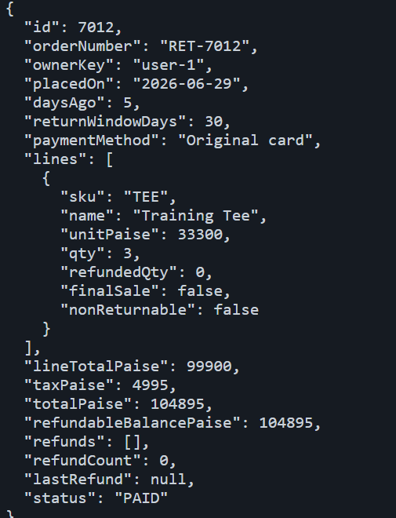

Here the tax is 4995 but we are giving floating value to it so it fail
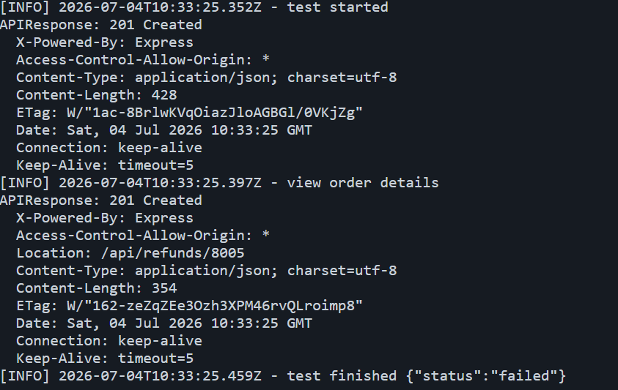

Scenario 3: Go Offline and make a an order and Sync when its Offline
Here the we have to go offline after we go to the page and queue a sale in offline and make it sync when internet is back.
Here for the testing we are making it offline before itself we navigate to the pos page
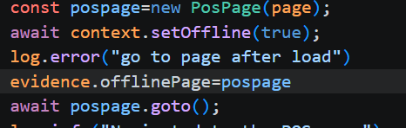
So this will create an error hence we are going offline before loading itself
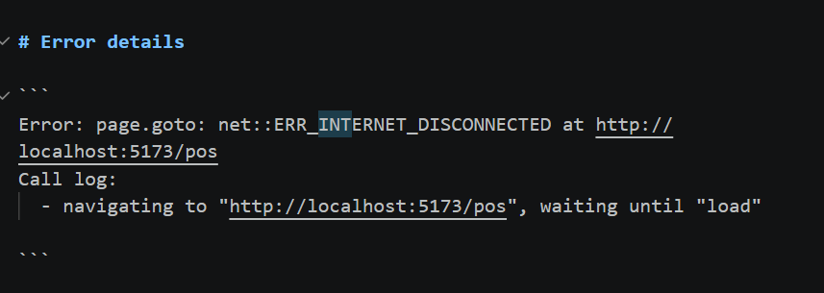
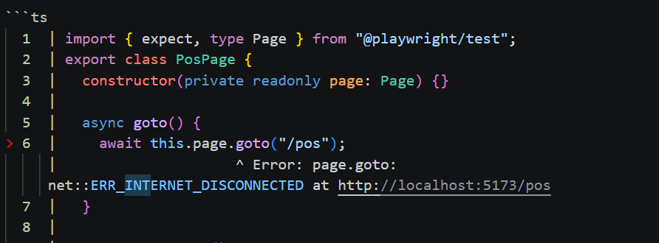
so to resolve it we are going offline after loading the page
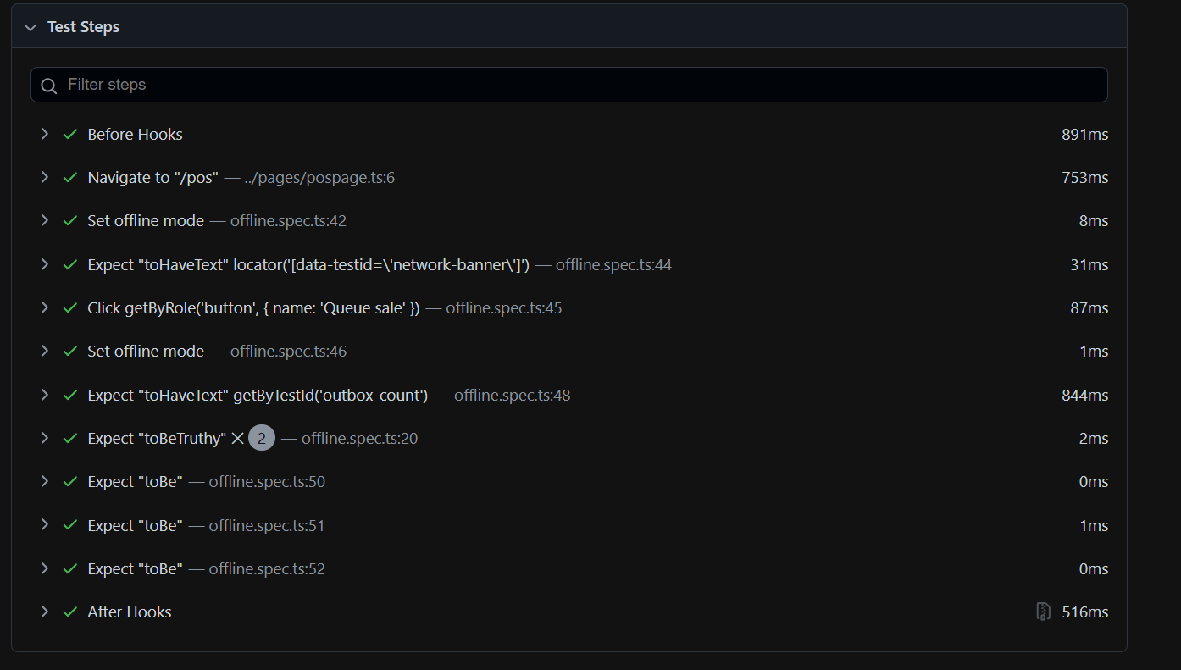
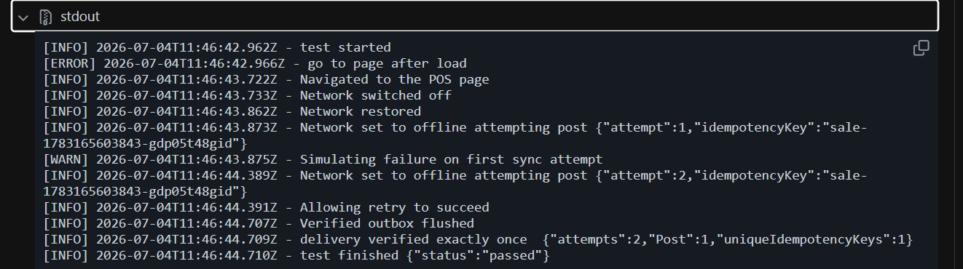
After loading the page the we will go offline and queue the sale so the queue will be locally stored after the system is online the queue will synced with POS sales and the out box count will be set to zero
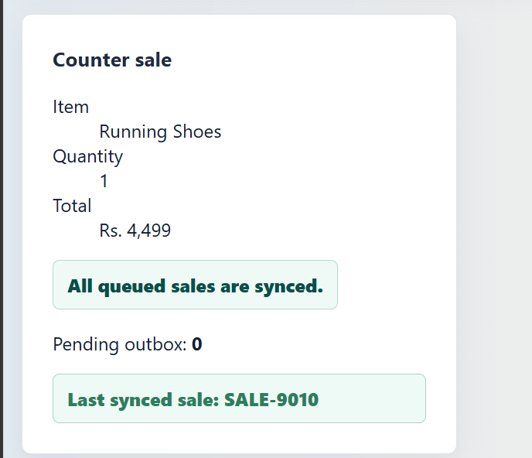

Scenario 4: Idempotent Key and checking for duplicate refund
Here we are creating an order and for refund we have to pass an idempotent key so when we don’t pass the idempotent key the refund will be initiated twice because those are two request
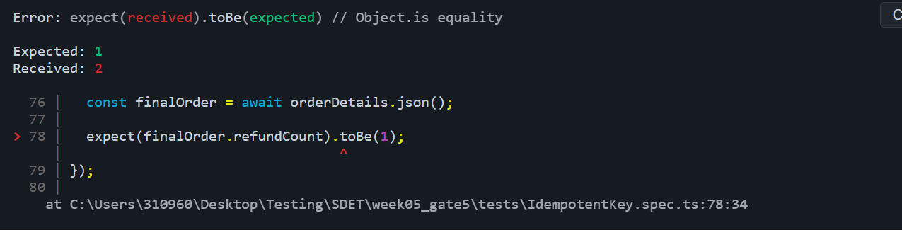
so we are creating a specific key for it
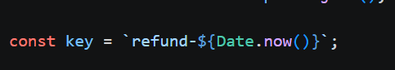
so when we use this key to twice in a refund it will only initiate refund once because the key is same
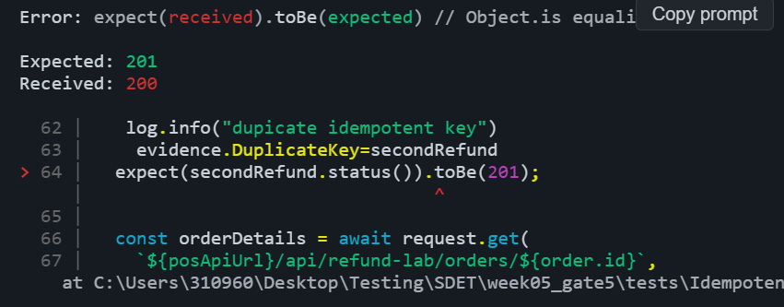

So this refund will not be created(201) it only will return ok response(200) like below
